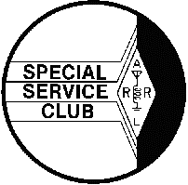  January 2001 | The HARC Spark  The Official Newsletter of the  Holmesburg Amateur Radio Club  P.O. Box 6253 Philadelphia, PA 19136  146.685 Mhz Repeater -Packet BBS KB3BTF 145.030 Mhz  Web Site http://www.harcnet.org | 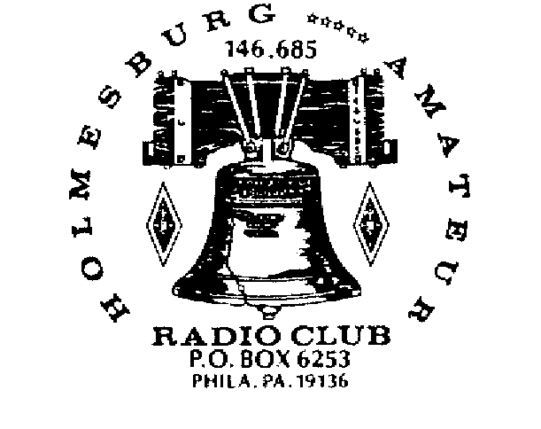  Editor: WA3PZO

PREZ SAYS…..
Are you ready for the new year?
HARC has been extremely active in 2000. We've made the national amateur radio scene a few times through contests, the ARRL, and the work of our members. We've had a successful picnic and many good club meetings. The repeater keeps functioning, the web page is on-line, nets are on the air as well as some of the latest news in amateur radio. None of this just happens. It's the work of some dedicated volunteers. Can we do more? Of course! Already in 2001 we have an exciting 2 Meter contest coming up and the Director of Medishare, WB3FTJ, speaking at our January meeting.
Over the summer we'll be participating in Field Day and who knows what else.
Elsewhere in the newsletter you will find a ballot for election of officers. You will find it looks much like the current board. We hope that you will consider getting involved. Maybe you want to throw your hat into the ring as a write-in. Maybe you would like to work on a specific project. Whatever the case, take some time and get involved. This month marks 30 years for me being involved with this great hobby. I haven't stopped learning yet. I enjoy learning about the old as well as the new. Ham Radio continues to change, but it is still bringing people together to share a common interest of communication.
Although the holiday period kept me away from the newsletter, I want to thank every member of HARC for what they have done for the Club. A wish from our home to yours for a prosperous new year. 73s
Bob, WA3PZO
HARC PREZ APPOINTED ARRL EPA ASSISTANT SECTION MANAGER & PUBLIC INFORMATION COORDINATOR
WA3PZO ready for the challenge
HARC President Bob Josuweit, WA3PZO, has been tapped by Eastern Pennsylvania Section Manager Eric Olena, WB3FPL to serve in two key positions in the ARRL Field Organization. They are Assistant Section Manager and Public Information Coordinator. Olena took office January 1. Josuweit has previously served as an ASM. He is qualified to be Public Information Coordinator. Josuweit, majored in Public Relations at Temple University, edited various newsletters, and received the ARRL's McGann Public Relations award for bringing a Ukranian ham to this country for medical treatment. He has reported on amateur radio public service for the past 4 years for CQ VHF and CQ.
According to the ARRL, the ASM may serve as a general assistant to the Section Manger or as a specialist. The Public Information Coordinator is the section's expert on public information and public relations matters. The PIC is responsible for organizing, training, guiding and coordinating the activities of the Public Information Officers within the section.
CLASSES ON HOLD!
New Ham Classes will not be starting in mid-January as mentioned in the membership letter. Although we were hopeful after being invited over to Lincoln High School to fill out the proper paperwork, the school will not be able to host us at this time. The problem involves construction work being done in the school. During the times we would be in the building there are no additional classrooms available. LHS is only opening a portion of the building. According to WA3PZO, the principal expressed interest in having us over, but he did not expect the construction work to be done in time.

INSURANCE NEWS

ARRL "All Risk" Ham Radio Equipment Insurance Plan administrator has announced that, effective immediately, the plan will insure antennas, towers and rotators. Coverage for antennas, towers and rotators may be written only as an endorsement--or rider--to an existing policy. As in the existing program, the policy is that all the equipment must be scheduled. Members may not insure antennas, tower, and rotators without also purchasing coverage for their other station equipment. The cost of coverage is $1.50 for every $100 of valuation--the same as that for station equipment. US Amateurs with further questions can contact the Seabury & Smith Customer Service Department at 800-503-9230.
FROM OUR SECTION MANAGER
By Eric, WB3FPL
Greetings to everyone. For those of you who do not know me I have been selected to fill the ARRL Eastern Pa. Section Manger's position from January 1, 2001 until 2002. I am definitely not a newcomer to the Eastern Pa. Section. I was first licensed in 1977 and 1979 I assumed the duties of Emergency Coordinator in Berks County.
In August of 1988 I became District Emergency Coordinator (Berks, Schuykill, and Carbon Counties). In April of 1990 I became Section Emergency Coordinator for EPA.
In October of 1992, I resigned as SEC due to employment change but I remained on the EPA section staff as Assistant Section Manager, serving as ASM until 1996.
In August of 1994 I was asked again to be SEC. I remained as SEC until assuming the duties as SM. Since approximately 1990 I have been representing the ARRL and all volunteer radio organizations at the Pennsylvania Emergency Management (PEMA) Volunteer Organizations in Disasters Committee (VOAD). My professional duties also reflect my commitment to radio communications.
I retired in 1992 after twenty-five and one half years with the Pennsylvania State Police. Six of those years I was assistant and the Troop Communications Specialist. I retired from the PSP to become Assistant Director of Communications at the Berks County Community Center. In October of 2000 I retired from County employment so that I can devote more of my time to handling the duties that come with the volunteer position, SM. (not to mention my XYL's "honey do" list).
I feel extremely lucky to be retired at 56 and be able to pursue pleasures and responsibilities that come with such a great hobby as amateur radio. The only items I bring to the table as SM is what can I and my staff do for our fellow EPA amateurs and what could we do to help promote amateur radio as a great and varied hobby. As I always advised the employees at the county communications center, my door is always open for what ever you need to discuss. I may not know all of the answers but I will certainly do my best to bring any question or problem to a reasonable solution. Eric D. Olena, WB3FPL
Using Linked Text for Parallel Articles
You can use linked text boxes to flow text in parallel “columns” from page to page. This method gives different results than using the Column command on the Format menu, which causes text in column 1 to flow or “snake” to column 2 on the same page. By using linked text boxes, you can instead have text from column 1 flow to column 1 on the next page. The text beside it in column 2 can flow to column 2 on the next page, parallel to column 1. This technique is useful if you need to group two similar articles, for instance, an article translated in English on the left and the same article translated in French on the right.
To flow text in parallel, display paragraph marks in your document. Click at the top of the page where you want the side-by-side columns to start, and press Enter twice. Click in the first paragraph mark on the page. On the Insert menu, click Text Box and drag on the page where you want the first column. Click Text Box again and then click and drag where you want the second column. Click in the last paragraph mark on the page, and press Ctrl + Enter to create a page break.
Repeat the process for each page that will contain side-by-side columns in your document and then return to the first text box you created. Click the text box on the left once to select it. Click your right mouse button and then click Create Text Box Link. The pointer becomes a pitcher. Click the text box on the left side of the second page to create a link. Create links for all text boxes within the same article on the left side of the document. Repeat the process for every text box in the right chain or article.
Pressing Enter twice at the top of each page will create an extra empty paragraph. This blank paragraph is useful if you want to insert text or graphics outside of the text boxes. You can delete the extra blank paragraph if you don't need it.
Copying linked text boxes
You can copy an article or a chain of text boxes that are linked together, to another document or to another location in the same document. To copy linked text boxes and the text they contain, you must copy all the linked text boxes in an article. Select the first text box in an article. Hold down Shift, and click each additional text boxes you want to copy. On the Edit menu, click Copy. Click where you want to copy the text boxes and then click Paste.
To copy some of the text from an article, select the text you want to copy from the article and then copy it. Do not select the text box. You can paste text you’ve copied directly into your document, into another location within the same article, or into another article.
AREA CLUBS LOOKING FORWARD
TO LOCAL CONTEST
Clubs in New Jersey and Pennsylvania are responding favorably to the Delaware Valley 2 Meter FM Simplex Contest to be held Saturday, February 3,
2001. "Excellent idea!!!!!!!", says Art, KA2DOT, President of the Gloucester County Amateur Radio Club. "2 meters is dead around here, it seems, on a
Saturday night." Rich, W3WJC, President of the Reading Radio Club writes, "The contest idea looks neat. A good idea using ZIP codes, more fun then grid
squares. Good job setting it up." Other clubs are just as excited. Bob Lees, W3ZQN, Montgomery County RACES Radio Officer sees another good point to the contest. Here’s an opportunity to test our communication's capability with the use of a repeater.
The contest is open to all radio amateurs. Stations within a 60 mile radius of Philadelphia's City Hall will exchange their zip code and contact number. Stations outside of the 60 mile radius will exchange their state and contact number. Stations from New York to Maryland will be able to participate in this evening event.
According to HARC President Bob Josuweit, WA3PZO, the contest is designed for hams to have fun over a 4 hour period from 7-11 PM on a Saturday night.
The contest allows hams to meet their neighbors on the air as well as give many the opportunity to experience something else besides repeater contacts.
The 60 mile radius reaches just about all of the county boundaries surrounding Philadelphia. This also opens up an opportunity for approximately 60 clubs to participate in the event. When choosing City Hall as the center of the contest, Josuweit noted the statue of William Penn on top of City Hall. "What better center point for the contest and the sponsoring organization whose club call is WM3PEN."
The contest gives individuals as well as clubs to participate in the event. Bonus points are being allowed for contacting club stations/callsigns.
"We realize that everyone will not be able to contact WM3PEN so we're giving clubs a chance to put their club callsign on the air." This could be from a
club station or an individual's home. Contacts can be made on any 2 meter FM voice frequency provided there is no interference to repeater, digital, satellite, or other activities taking place in the two meter band. Contacts on 146.52 will not be permitted. HARC members are excited about the event. Here's a contest where they can
(Contest)
spend a few hours on the radio, participate in a contest, and not be tied up for an entire day or weekend.
Awards will be issued to individual top scores in a high and low power category. An award will also be issued for the highest mobile score. For further information contact WM3PEN@harcnet.org or WA3PZO@harcnet.org.

SAMPLE CONTACT EXCHANGE
1. If you live in the 60 mile radius of William Penn (Philadelphia City Hall)
KB3AKK de WA3PZO Pse copy Nr.1 zip 19136
2. If you live outside of the 60 mile radius
WA3PZO de N3EFN Pse copy Nr. 1 PA.
3. If you work HARC's club call WM3PEN exchange your information and make a note that it is the sponsoring club call and worth 3 points. Other club calls will be worth 2 points. All other contacts count as 1 point. Final score will be the number of contacts X the number of zip codes/states in high (10W or
more) and low power (less than 10W) categories. Individual, club station, and mobile awards will be issued. Clubs can issue their own membership awards. A list of zip codes up to 60 miles from Philadelphia's City Hall is available.
ENTRY DEADLINE: All logs, either paper or electronic should be received by February 28, 2001. Logs may be sent to the Holmesburg Amateur Radio Club, PO
Box 6253, Philadelphia, PA 19136 or emailed to WM3PEN@harcnet.org.
|||||||||||||||||||||||||||||||||||||||||||||||||||||||||||||||||||||||||||||||||||||||||||||||||||||||||||||||||||||||||
(Marconi-cont.)
The Phototransistor may exhibit better performance if a battery supply voltage of greater than 1.5 Volt is used, but the supply voltage is limited to less than 10 Volts. The Marconi Challenge transmits infrared light and any method (other than fiber optics) can be used to focus and capture the optical transmission. The Infrared LED claims to have a
viewing angle to half-intensity of 45 degrees. This spreads the available signal, but an optical system can be used to decrease the viewing angle. The infrared LED can also be physically modified if required. The single Phototransistor can use any optical collection system to maximize VRCV and minimize ambient light.
The Competition will be held in the College of Engineering Building, 12th and Norris Streets, Philadelphia, on Saturday February 24, 2001starting at 10:00 AM. Lunch will be provided for participants. Tours of the engineering laboratories and computer facilities will be available. Prizes include $100 for first place, $50 for second place
and $25 for third place. Duplicate Prizes will be awarded to Temple University students. Make your reservations now! Reservations and questions can be directed to:
Prof. Dennis Silage 215-204-6761 silage@vm.temple.edu

Byline Company - Use this style to type the author’s company.
Sidebar Head - Use this style to type a second-level heading in a sidebar article.
Sidebar Subhead - Use this style to type a third-level heading in a sidebar article.
Sidebar Text - Use this style to type the text in a sidebar article.
Sidebar Title - Use this style to type first-level headings in a sidebar article.
Footer - Use this style to type the repeating text at the very bottom of each page.
Heading1 - Use this style to create headlines for each article.
Heading2 - Use this style to create section headings in an article.
Jump To and Jump From - Use these styles to indicate that an article continues on another page.
Mailing Address - Use this style in a mailing label to type the destination address.
Postage - Use this style in a mailing label to type postage information.
Return Address - Use this style in a mailing label to type your address.
Picture Caption - Use this style to type a description of a picture or illustration.
Subtitle - Use this style to type sub-headings in an article.
Use PullQuote to excerpt text from the main text of a story to draw a reader’s attention to the page. See page 4 for an example.

Inside This Issue
1 | Contest Plans Continue
3 | HARC Prez tap by ARRL Section Manager
4 | Temple sponsors Marconi Challenge
5 | Will the real QVC please stand up!
7 | Elections
continued on page 4

JANUARY-FEBRUARY ACTIVITIES

SUNDAY | MONDAY | TUESDAY | WEDNESDAY | THURSDAY | FRIDAY | SATERDAY
7  ARRL RTTY Roundup | 8 | 9  Chaverim 9pm | 10  CW Practice: 7:30  Members net: 8:00 | 11 | 12 | 13
14 | 15 | 16  Chaverim 9pm  Board Mtg 7:30 | 17  CW Practice: 7:30  Members net: 8:00 | 18 | 19 | 20  ARRL January VHF Sweepstakes
21 | 22 | 23  Chaverim 9pm | 24  CW Practice: 7:30  Members net: 8:00 | 25  HARC MEETING 8pm | 26 | 27
28 | 29 | 30  Chaverim 9pm | 31  CW Practice: 7:30  Members net: 8:00 | 1 | 2 | 3  Delaware Valley 2 Meter Contest
4 | 5 | 6  Chaverim 9pm | 7  CW Practice: 7:30  Members net: 8:00 | 8 | 9 | 10
11 | 12 | 13  Chaverim 9pm  Board Mtg 7:30 | 14  CW Practice: 7:30  Members net: 8:00 | 15 | 16 | 17

Dates to Note: January25 ^{th} HARC meeting - Gene Hoenig, WB3FTJ will speak on the Medical Amateur Radio Council and
Medishare.

Next general meeting will be January 25th. Election of Officers will take place.

Delaware Valley 2 Meter Contest: Saturday February 3rd. See this issue for more details.

H.A.R.C. Board Of Directors 2000  HARC is an  ARRL Special Service Club.  President : WA3PZO : Bob Josuweit  Vice Pres. : N3LXN : Mike Wurgley  Treasurer : W3KZA : Sid Kalos  Secretary : KB3AKK Dave Hogan  Trustee : KB3SM : Bob Brocklehurst  Trustee : KB3EBG : Peter Santiago  Trustee : KB3AAJ : Ron Slattery  Tech Committee : WB3BDC : Ron Cardullo  Editor : WA3PZO: Bob Josuweit  _____________________________________________  H.A.R.C. Maintains a Web Page @www.harcnet.org  All members Online can be emailed via theircallsign  @harcnet.org. Articles, pictures etc. submitted for the newsletter should be in standard ASCII or MS Word, .jpg or .gif formats and E-mailed to the Editor no later than the 2nd Saturday to be included in the next edition!  WA3PZO@Harcnet.org.  __________________________________________  H.A.R.C. Nets meet on 146.685 weekly  The Chaverim Net: Tuesday @ 9:00 PM  CW Practice: Wednesday @ 7:30 PM  Members net: Wednesday @ 8:00 PM you can listen to the Amateur Newsline & ARRL audio reports.  SSB Net on 28.450 +- mhz Sundays @ 9:00 AM  __________________________________________  H.A.R.C. Monthly Meetings - The board of directors meets on the 2nd Tues. @ 7:30 PM. General meetings are held the last Thurs. @8:00 PM. | + Marks the boundary of the buildings, the actual entrance is located where Rt. 232 Intersects. Stop at the guardhouse and ask if you’re not sure where to go...  The Naval ASO 700 Robbins St. Phila PA 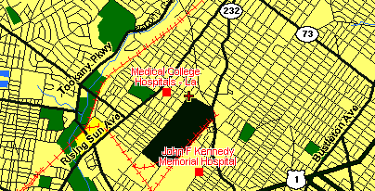  H.A.R.C maintains the 146.685 repeater located @ Univ. of PA., Phila PA with inputs in Abington, N.E. Phila, and Cherry Hill, NJ; More Club Information & Member Applications can be had by contacting any of the Directors via E-mail. Info@harcnet.org, the web page http://www.harcnet.org or writing to HARC PO Box 6253, Philadelphia, PA 19136.  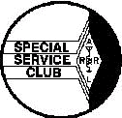

Engineer's Week 2001 Competition for High School
Students sponsored by the College of Engineering,
Temple University Saturday, February 24, 2001
Guglielmo Marconi pioneered wireless telegraphy using electromagnetic waves at a wavelength of about 1500 meters and succeeded in sending a signal with kilowatts of power across the Atlantic Ocean in 1901. The Marconi Challenge is to send an infrared (IR) signal at a wavelength of approximately 900 nanometers with milliwatts of power to a detector over the largest room-sized distance.
Standard equipment for the Marconi Challenge is a single Radio Shack High-Output Infrared LED (Light Emitting Diode) part number 276-143 as a Transmitter and a single Radio Shack Infrared Phototransistor part number 276-145 as a Receiver. A selection of resistors, a Volt-Ohm
Meter (VOM), and any optical apparatus would also be needed.
The Infrared LED as the Transmitter can be powered by a single nominal 1.5 Volt battery. The voltage drop that appears across the LED is about 1.2 V and the maximum current is 100 milliamperes (mA). The Marconi Challenge limits the LED current to no more than 75 mA, which
will be measured during the Competition. You should use Ohm's Law (V =I R) to determine the appropriate series current-limiting resistor RLED. The cathode of the LED is connected to the negative terminal of the battery. The positive terminal is connected to RLED and the other
lead of RLED is connected to the anode of the LED.
The Infrared Phototransistor is a NPN silicon device with two terminals: collector and emitter. As little as a single nominal 1.5 Volt battery can be used to power the Phototransistor as the Receiver. An appropriate series load resistor RLOAD (start with 1000 ohms) is connected from the positive terminal of the battery to the collector of
the Phototransistor. The emitter of the Phototransistor is connected to the negative terminal of the battery. The received voltage signal VRCV of the Marconi Challenge is then measured with the VOM across the collector and emitter terminals of the Phototransistor.
The Competition of the Marconi Challenge is to produce a measurable received signal VRCV over the greatest distance between the LED transmitter and Phototransistor. The measurable signal is defined as at least a 10% change in VRCV from that due to ambient light VAMB as the LED transmitter is keyed ON and OFF, simulating a Morse code
transmission. The Phototransistor will respond to ambient light and designs are suggested to minimize this affect. The Marconi Challenge will be held in a darkened (overhead lights off) lecture room.
Designs include choosing a value for RLED to provide the required current and a value for RLOAD that maximizes VRCV without saturating the received signal because of the ambient light. Several, switch selectable values of RLOAD can provide a dynamic range for the Receiver.

continued from page 1

SPECIAL EVENTS
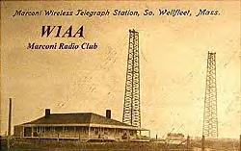
W1AA/CC: The Marconi Radio Club W1AA will celebrate the 98th anniversary of Marconi's first transatlantic radio transmission with a special event operation on January 18 from Cape Cod, the site of Marconi's original station. The club will operate two HF stations identifying as W1AA/CC. "CC" was the call sign Marconi used in 1903.Operating hours will be from 1200-2200 UTC on 20 through 10 meters, CW and SSB. DX stations QSL via the W1 Bureau, and US stations via the W1AA database address with an SASE. Since almost all of the original 1903 Marconi station site has been carried away by beach erosion, operation will be from a former Coast Guard life boat station.--Whitey Doherty, K1VV (ARRL Web Page).

SUPER BOWL FEVER
WEIRD AND WONDERFUL - PIG SKIN FUN According to Fred Maia's W5YI Report, one of the most concentrated R-F environments on any given Saturday can be a National Football League Stadium. It appears as if everyone from coaches to players to officials to television crews are using wireless devices in the stadiums across the USA. Now, so as to keep the various users of R-F gear from bothering one another the N-F-L is now providing official frequency coordinators at each stadium during the regular season. And you thought it was hard getting a channel pair for your new repeater. (W5YI via ARNewsline via QNEWS)

WA3PZO TO SPEAK AT MONTCO RACES
HARC Prez WA3PZO will be speaking at the January 27 meeting of the Montgomery County RACES at the County Emergency Operations Center in Eagleville. Time is 10 A.M. WA3PZO will be wearing many hats as CQ's Public Service Editor speaking on "Public Service - Challenges for the Future" and as HARC's President introducing our Club to the Group. If you are interested in attending contact WA3PZO.
In Sincere Sympathy…
HARC extends it's sympathy to Sol Volen, N3UBY, whose wife passed away in November.
West Chester Based QVC takes on U.S. Ham
The well known cable retailer QVC has demanded that N7QVC remove his domain name (www.n7qvc.com) for " infringement of the QVC marks." The complaint goes on to say, "In addition, your use of N7QVC.COM constitutes false advertising, because it misrepresents the nature, characteristics, qualities and origin of your commercial activities. Your use of N7QVC.COM also dilutes the distinctiveness of our client's well-known marks. Our client, therefore, demands that you immediately cancel and delete the registration for N7QVC.COM and permanently refrain from any use of any imitation of the QVC mark."
Warning! - Within hours of this information being posted on the web, the site was attacked by a hacker and the site was directed to a pornographic site. At press time efforts were being made to restore the site to it's original family and amateur radio content.
At Issue.. At minimum will be the question as to whether a business can tell an individual not to use his name or identity supplied by and agency of the U.S. Government. Stay tune for further details.
==========================================
Other web problems
Arguably the best site on the Web for information about classic American “hollow state” radios in general and Hallicrafters gear in particular, the www.hallicrafters.org web site was permanently shut down on December 21, by it’s owner/creator and founder of the defunct Hallicrafters Collectors Association, Brad Stone NB9M. In his announcement of the shut down, Stone mentioned as one of his motivations the foundation of another site, www.hallicraters.net, the “home” of the “Hallicrafters Collectors International” group, and the actions of the owners and operators of that site in stealing the bulk
of the content (including photos from other collectors, Hallicrafters advertisements and memorabilia, articles, and so forth) from his site.
A key player in this content theft was Al Waller K3TKJ, owner of the www.qsl.net and www.qth.net servers, who provided space to store the content. In an email to interested
parties on December 19 th , Waller stated that he felt that the two sites and the organizations behind them came from the
“same gene pool” and that this justified his transfer of the content to the webmaster of the new site, Fred Mooney KA1DGL. This action also followed several weeks of
comments from Mooney and other HCI staff that Stone was going to shut down his site, so they were justified in raiding it. Stone finally decided to pull the plug on his site and move on to other things. (Courtesy WASHRag)

SCHOLARSHIPS AVAILABLE

The Foundation for Amateur Radio, Inc. , a non-profit organization with headquarters in Washington, D.C. plans to administer 67 scholarships for the academic year 2001-2002 to assist licensed radio amateurs. The Foundation--composed of more than 75 local area Amateur Radio clubs--fully funds 10 of these scholarships with the income from grants and its annual hamfest. The remaining 57 are administered by FAR without cost to the various donors.
Amateur Radio operators holding a valid license may compete for these awards if they plan to pursue a full-time course of studies beyond high school and are enrolled in or have been accepted for enrollment at an accredited university, college or technical school. The awards range from $500 to $2500 with preference given in some cases to residents of specified geographical areas or the pursuit of certain study programs. Clubs--especially those in Delaware, Florida, Maryland, Ohio, Pennsylvania, Texas, Virginia and Wisconsin--are encouraged to announce these opportunities at their meetings, in their club newsletters, during training classes, on their nets and on their web home pages.
Additional information and an application form are available by letter or QSL card request postmarked prior to April 30, 2001. Address requests to FAR Scholarships, PO Box 831, Riverdale, MD 20738.
The Foundation for Amateur Radio, incorporated in the District of Columbia, is an exempt organization under §501(c)(3) of the Internal Revenue Code of 1954. It is devoted exclusively to promoting the interests of Amateur Radio and those scientific, literary and educational pursuits that advance the purposes of the Amateur Radio Service.

LOCAL FCC ENFORCEMENT EFFORTS
(VIA ARRL)

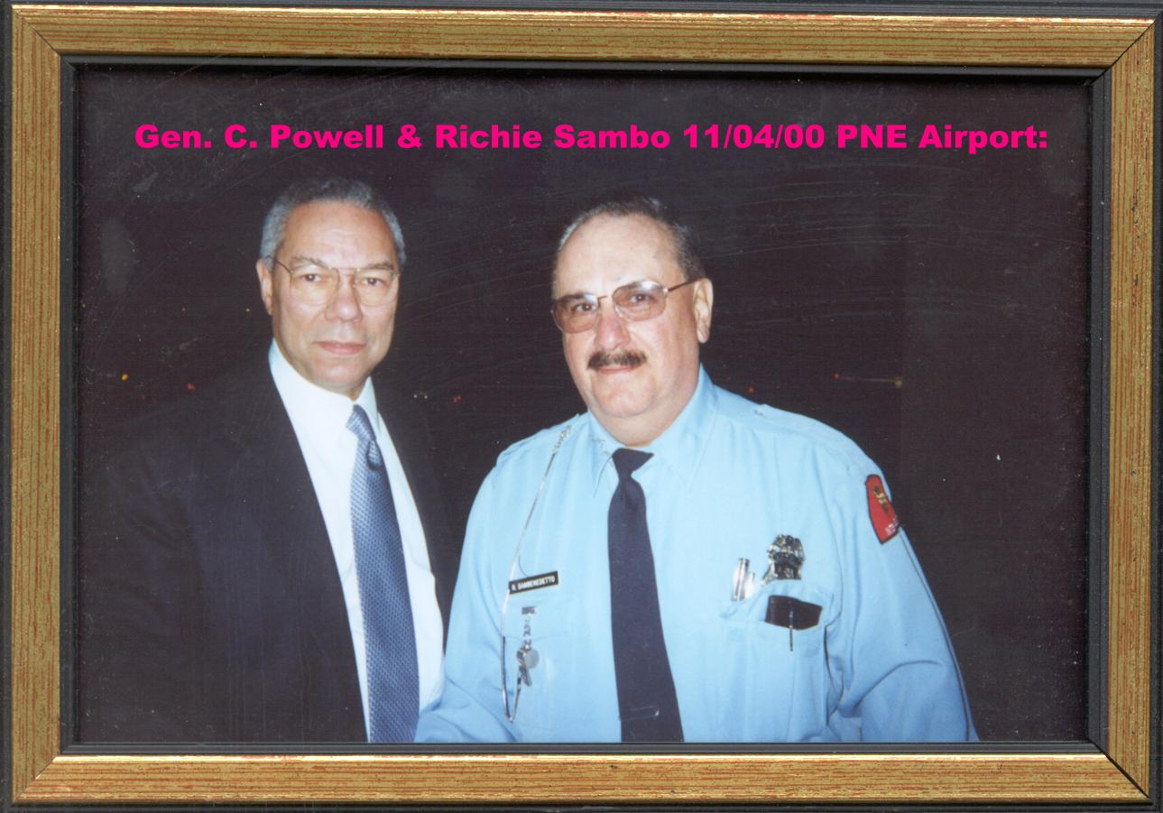
NEWTON SQUARE, PA: The FCC on December 22, 2000, sent a Warning Notice to General licensee Henry Schott Jr, KA3BMS, regarding his operation on the W3UER 147.36 MHz and WA3RVT 444.050 MHz repeaters. FCC Special Counsel for Amateur Radio Enforcement Riley Hollingsworth cited "information before the Commission" indicating that control operators of the two repeaters have requested Schott to not use those systems. "Information also indicates that you have keyed up the repeaters and interfered with existing communications, failed to identify, and used obscenities," Hollingsworth said. He advised Schott that he was expected to comply with the request of the control operators and that continued operation as alleged would result in enforcement action

WEST CONCORD, MA [UPDATE]: The FCC on December 18, 2000, adopted a consent decree terminating its forfeiture proceeding against Michael E. Gallagher, KB1DTA (ex-KB3DHX). In exchange for not having to pay a $7500 fine, Gallagher agreed to turn in his Technician license and not reapply for five years. He also must stay out of further trouble with the FCC. The FCC said Gallagher provided financial statements supporting his claim that paying the $7500 forfeiture would cause him financial hardship. The consent decree concludes the FCC's malicious interference investigation of Gallagher and Kornwell H. Chan, W3CI, of Dresher, Pennsylvania. Also facing a $7500 fine, Chan last year agreed to give up his ham ticket until 2003 and cooperated with the FCC in its investigation. In March 1999, Chan and Gallagher each were fined in connection with malicious interference to the Phil-Mont Mobile Radio Club VHF and UHF repeaters on two occasions the previous month. FCC personnel monitored interfering signals that included transmissions of classical music and a person talking with a disguised voice. FCC agents tracked the signal to a vehicle in Willow Grove, Pennsylvania, occupied by Chan and Gallagher and equipped with amateur gear. The FCC cited Chan and Gallagher for failing to operate "in accordance with good amateur practice," failing to identify as required, transmitting music on amateur frequencies, and willfully impeding legitimate amateur communications. According to the FCC Order adopting the consent decree, Gallagher told one of the FCC agents that he had transmitted with a disguised voice on the Phil-Mont repeater's output frequency and had not identified by call sign. The pair also reportedly had told FCC officials that Chan used Gallagher's station to transmit music on amateur frequencies. The FCC said Gallagher was "equally responsible" for transmissions made using his station. Gallagher responded to the Notice of Apparent Liability by admitting making interfering transmissions and agreeing to cooperate in the investigation. In the consent decree, Gallagher agrees to not contest the findings of the Notice of Apparent Liability that he violated FCC rules in February 1999, although the findings may not be used against him in any current or future proceedings--provided Gallagher does not violate FCC rules or the consent decree provisions.

RTTY by WF1B now a free program: Ray Ortgiesen, WF1B, has changed the way his RTTY contest software is distributed. From now on, RTTY by WF1B will be available free via the Internet. Users will pay a fee for support, however. WF1B is making the program's source code available and is soliciting suggested changes from programmers. For details, visit the RTTY by WF1B Web page (HTTP://WWW.WFIB.COM)

HARC Member Richie Sambo, WA3AOP, met with General Colen Powell, at Philadelphia's Northeast Airport in November.

MEMBERSHIP RENEWAL - DUES ARE NOW DUE!
Dues cover January 1, 2001 until December 31, 2001. All members in good standing are eligible to vote and hold a board office. Dues are $20.00/year. Family membership is $5.00 for other hams living in the same house.

NAME ________________________________________________ CALL_____________________

OTHER HOUSEHOLD MEMBERS: ____________________________________________________

ADDRESS _________________________________________________________________________

City, State, Zip _____________________________________________________________________

Telephone # _______________________ May we list telephone number in the directory? YES NO

Are you willing to receive your HARC newsletter via email? YES NO

E-mail ____________________________May we list your email address in the directory? YES NO
May we list your email address on the club web page? YES NO
Are you an ARRL member? YES NO Membership Expires (mm/yy) _____________

HARC is always looking for help on different projects. Would you be interested in helping on any of the following? (Circle all that apply)
Field Day Public Service Events Special Events BOD/Club Officer
Publicity Classes Newsletter Club Programs
Technical Nets Bulletin Info Other______________________

Make checks payable to H.A.R.C. and mail to PO BOX 6253, Philadelphia, PA 19136.

ELECTION OF OFFICERS

It's that time of year to vote for the HARC officers for the upcoming membership year. Ballots should be received by the January HARC Meeting (1/25/01). The can be mailed to the Club PO Box (PO BOX 6253, Philadelphia, PA 19136) or brought to the meeting. The Technical Chairman is appointed. Trustees serve on a rotating basis. HARC's 3 Members at Large rotate their term or service. KB3SM serves until the end of 2002. KB3EBG serves until the end of 2001. You may vote for one of the candidates listed or write in a choice. New officers take office on February 1. All ballots must be received by the Club no later than January 25, 2001. The may be brought to the Club meeting or mailed to the Club PO Box.

BALLOT FOR OFFICERS 2001

PRESIDENT:
Bob Josuweit, WA3PZO ___
____________________ ___

VICE PRESIDENT:
Mike Wurgley, N3LXN ___

MEMBER AT LARGE
KB3AAJ : Ron Slattery __
_________________ ___

SECRETARY:
Dave Hogan, KB3AKK ___
_________________ ___

TREASURER:
Syd Kalos, W3KZA ___
________________ ___

HOLMESBURG AMATEUR RADIO CLUB
P.O. Box 6253 Philadelphia, PA 19136

“Serving the Community Through Ham Radio”

SEE YOU AT THE JANUARY MEETING!

NEXT MEETING:

DATE: JANUARY 25, 2001

TIME: 8:00 PM

LOCATION: NAVAL ASO (OXFORD AND MARTIN MILLS ROAD)

TOPIC: MEDICAL AMATEUR RADIO COUNCIL & MEDISHARE

