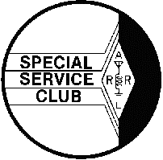  January 2002 | The HARC Spark  The Official Newsletter of the  Holmesburg Amateur Radio Club  P.O. Box 6253 Philadelphia, PA 19136  WA3AOP/R 146.685 Mhz Repeater  K3FI CLUB CALLS WM3PEN  Web Site http://www.harcnet.org | 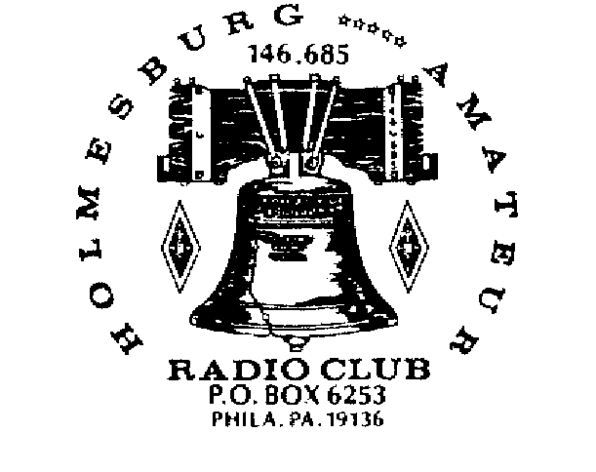  Editor: WA3PZO

PREZ SAYS..
Earlier this month President Bush called for the creation of a volunteer civil defense service and told the American people that the specter of a long war against terrorism within the United States would force the country to confront "new responsibilities, both for the government and for our people."
If you have been in ham radio for sometime, you are probably aware that hams were very active in the days of civil defense. In many communities amateur radio public service communications continues to be important.
This week I received a phone call from the Temple University Health System. Temple has six hospitals in Northeast Philadelphia and one in Bristol. They are interested in establishing amateur radio as an emergency communications service. We'll be meeting with them in the near future to see what they have in mind.
It's almost the end of the year. Wow the past few months have gone by so fast. HARC is still on the move. Our programs continue to be top notch with representatives from the Battleship NJ and QST's Oldtime Radio Editor K2TQN. This month we have another national speaker, WT3P, talking about ARRL's Big Project. Looking ahead to January we'll have a presentation on amateur radio emergency communications when EPA ARRL Section Manager WB3FPL will be speaking.
We'll have more news about elections, a club raffle, and much, much more.

Until next time….73s Bob, WA3PZO

CLUB ELECTIONS

It's that time of year to elect representatives to your HARC Board of Directors. This year the position of President, Vice President, Secretary, Treasurer, and one member at large are up for nominations. WA3PZO has indicated that he is not running for President this year and KB3AKK's work schedule has made it difficult for him to attend meetings. KB3EBG's term is up as member at large. All are eligible run again for office.
If you are interested in running for office contact WA3PZO. Nominations should be received by February 10, 2002. Ballots will be in the February newsletter. All ballots must be received by mail or in person by February 28. The 2002 Board will take office March 1.

$ DUES ARE DUE $

If you haven't paid your dues, your membership in HARC has run out. The HARC membership year runs January to December. At $20/year membership is a bargain. Dues are cheaper than other major clubs in the area. At the same time HARC is one of the few ARRL Special Service Clubs in the area. Dues can be paid at the January 31 Club meeting or can be sent to the Club PO Box.

CLUB MEETINGS
8th District Police Station
8 PM

On January 31st EPA ARRL Section Manager Eric Olena, WB3FPL, will talk about public service and other ARRL activities. At the meeting we will have our fund raising tickets for the Icom PCR-1000 shortwave receiver. Also we will be holding a drawing for a 2002 ARRL Handbook.
On February 28th the topic will be the Ham Radio Olympics. We'll learn about the 2000 World Radiosport Championship in Yugoslavia. In addition you'll have the opportunity to see one of the few Olympic medals awarded to a ham radio operator.

.

H.A.R.C. Board Of Directors 2001  HARC is an  ARRL Special Service Club.  President : WA3PZO : Bob Josuweit  Vice Pres. : N3LXN : Mike Wurgley  Treasurer : W3KZA : Sid Kalos  Secretary : KB3AKK: Dave Hogan  Trustee : KB3SM : Bob Brocklehurst  Trustee : KB3EBG : Peter Santiago  Trustee : KB3AAJ : Ron Slattery  Tech Committee : WB3BDC : Ron Cardullo  Editor : WA3PZO: Bob Josuweit  _____________________________________________  H.A.R.C. Maintains a Web Page @www.harcnet.org  All members online can be emailed via theircallsign  @harcnet.org. Articles, pictures etc. submitted for the newsletter should be in standard ASCII or MS Word, .jpg or .gif formats and E-mailed to the Editor no later than the 2nd Saturday of month to be included in the next edition!  WA3PZO@Harcnet.org.  __________________________________________  H.A.R.C. Nets meet on 146.685 weekly  The Chaverim Net: Tuesday @ 9:00 PM  CW Practice: Wednesday @ 7:30 PM  Members net: Wednesday @ 8:00 PM you can listen to the Amateur Newsline & ARRL audio reports.  SSB Net on 28.450 +- mhz Sundays @ 9:00 AM  __________________________________________  H.A.R.C. Monthly Meetings - The Board of Directors meets on the 2nd Tues. @ 8:00 PM. General meetings are held the last Thurs. @8:00 PM. | 8th District Police Station,  Red Lion & Academy Rd. Phila PA  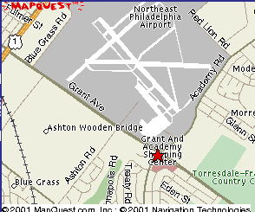  H.A.R.C maintains the 146.685 repeater located @ Univ. of PA., Phila PA with inputs in Abington, N.E. Phila, and Cherry Hill, NJ; More Club Information & Member Applications can be had by contacting any of the Directors via E-mail. Info@harcnet.org, the web page http://www.harcnet.org or writing to HARC PO Box 6253, Philadelphia, PA 19136.  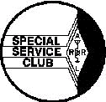

AMATEUR LICENSE INFORMATION

Renewing your Amateur Service FCC license, or changing your license address, call sign or name, or requesting a duplicate license. Amateurs have several options for renewals or filing changes. They include:
* As a free service to ARRL Members, ARRL Members may complete and sign an NCVEC Form 605 (http://www.arrl.org/arrlvec/ncvec605-3.pdf) and return it to
ARRL HQ. ARRL HQ staff will in turn file the application data electronically with the FCC. The processing time will take only a few days or less once the application reaches ARRL HQ. Send such applications to:
ARRL VEC, 225 Main St, Newington CT 06111 USA.
Non members are welcome to first sign up for membership and then use this service. For membership info, including an on-line membership application, see http://www.arrl.org/join.html. For NCVEC Form 605
see http://www.arrl.org/fcc/forms.html. If preferred, non members can mail a check (or the credit card charge info) for the applicable current membership rate for themselves in the same envelope with a completed NCVEC Form 605 and ARRL HQ will immediately process the membership request and shortly thereafter the NCVEC Form 605 FCC license renewal/update request. Vanity requests must
still be handled separately by mail or on line directly with the FCC (or via someone serving as a filing agent, such as the W5YI Group).
* All Amateurs can apply by mail with FCC. To place your request by mail obtain an "FCC" Form 605, complete it and then mail it to: FCC, 1270 Fairfield Rd, Gettysburg PA 17325. This is a free FCC service. FCC Form 605 can be obtained via http://www.arrl.org/fcc/forms.html or
ftp://ftp.fcc.gov/pub/Forms/ or via fax to FCC's Fax-On-Demand system at 202-418-0177 (request form number 000605).
* All Amateurs can apply via the internet. The FCC accepts submissions electronically via their Universal Licensing Service (ULS) system.
You may file requests via: http://wireless.fcc.gov/uls/. To use the on-line ULS system, you must first be sure you are using a web browser which FCC indicates is fully functional for ULS use (FCC indicates that at present only recent versions of Netscape {vers. 4.7x work well} are fully tested
and functional); you must then registered in ULS, which involves supplying your Taxpayer ID Number (TIN) which is your Social Security Number to FCC.

PHILLY TECHFEST A HIT!
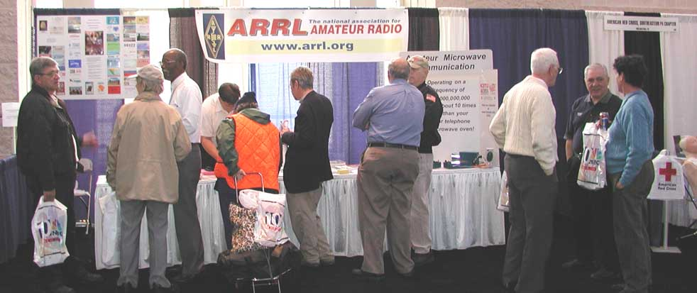
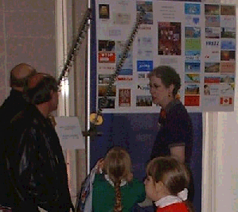
Philadelphia--Hundreds of Philadelphia-area residents visited the ARRL booth at the NBC10 Family TechFest, December 1-2. "We had a chance to present ham radio to a large number of people whom we might not otherwise reach," said ARRL Vice President Kay Craigie, WT3P. "A lot of kids were there." Craigie said the most common questions were "What's this all about?" and "Ham radio? I didn't know they did that any more." Quite a few amateurs also stopped by the booth, she said.
W3STW, WA3PZO, W3DCL, & K3DS AT TECHFEST(photo - WT3P)
Booth visitors were treated to a satellite presentation by Al Tribble, W3STW, and a 10-GHz demonstration by Temple University engineering professor (and Atlantic Division Assistant Director) Dennis Silage, K3DS, and the Temple University Amateur Radio Club. Eastern Pennsylvania Section Manager Eric Olena, WB3FPL, Eastern Pennsylvania Public Information Coordinator Bob Josuweit, WA3PZO, and past EPA PIC Jim Biddle, W3DCL, also were on hand to greet visitors and answer questions.
WT3P talks about satellite communication
(WA3PZO photo)
"With over 10,000 people attending the Family TechFest, it was exciting to see activity at the ARRL booth," Josuweit said. He pointed out that the emphasis was on conveying some of the excitement of Amateur Radio as well as describing its educational benefits--although exhibit hall restrictions precluded setting up a working ham station.
"Many were amazed at the advancements in ham radio," he said. "They had associated ham radio being a Morse code-only hobby." Josuweit said visitors were interested to find out that hams also learn about geography, space, science, and various lifestyles and cultures in the course of their radio operating activities.
The Family TechFest also offered opportunities to speak with educators in junior and senior high schools, charter and private schools as well as with those involved with home schooling. In addition, Josuweit said, several Scout leaders dropped by to learn more about the hobby and how it could tie in with the Radio merit badge. Craigie said many of those who gravitated to the ARRL exhibit "seemed genuinely interested in what we had to show and tell," and the booth staff was ready to handle all comers.
"The group was diverse in our ham radio interests," she noted. "Every person could talk about ham radio in plain English to people who never heard of it before."
Josuweit said it was also important to have people who were familiar with the many clubs in the area and could "work the crowd." For example, he said, Biddle's technique was to first chat with visitors to find out what they were interested in, then show them how ham radio could fit into their lifestyle.
Josuweit said events like TechFest can prove important to the growth of ham radio. "We're busy setting up license classes for those who want to join in the fun," he said, adding that visitors showing an interest were encouraged to consider Now You're Talking, the ARRL's basic ham radio study guide. "We had a copy of the book, so we were able to show how easy it is to study for the test."
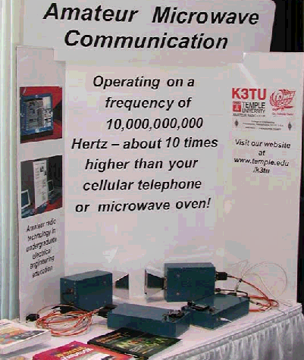
During the event, NBC10 News interviewed Craigie about ham radio. She explained what ham radio was and some of its benefits, and the story aired on the station's noon, 6 PM and 11 PM newscasts.
Craigie expressed her appreciation to Paul Sokoloff, WA3GFZ, an employee of NBC10, which sponsored the TechFest. ARRL had a free exhibitor's booth, she said.
WT3P photo
Olena termed the event "a definite success."

Sightless ham tells story about ham radio in the Philadelphia area!
(This is the fifth of a series of articles by T. A. Benham W3DD, who lives in suburban Philadelphia. The articles are from the Handi-Hams email newsletter.)
Becoming a Ham - Part 5
By T. A. Benham, W3DD
Operating from a different location
I had always wanted to be able to operate my Ham equipment from another location, so I asked if I could bring my radio along to summer camp. I thought Maine would be an interesting spot because I often heard Maine Hams talking to exotic places, areas that I couldn't hear from home. The Director agreed that if I could confine
the entire station to a box no larger than 1 by1 by 3 feet, it could
be transported in his wagon. I built a station within the prescribed
limits. A picture of it appeared in the Ham magazine QST later in
1934. A copy of the picture hangs on my desk today. It was in the
form of a three-shelf case. The top shelf held the receiver, the
middle shelf contained the transmitter and the bottom held the power
supply. Shortly after arriving at camp, a few of my friends helped me
set up in a little shack the Director turned over to the project. We
strung up a relatively crude antenna, tuned up the rig, and I was on
the air, CW of course. I spent a good deal of time in the shack, but
not as much as I thought I would. There were too many other things to
keep me active and not as many exotic contacts as I had hoped, as the
ionospheric conditions were not very favorable. However, the contacts
I made were worth the trouble of getting the equipment ready and
installed.
Activities in Germany
In the spring of 1936, I received a scholarship to spend the summer
at the University of Munich in Germany. Since I didn't want to go
alone, I asked my friend Sandy (W1ILF) to go with me. He agreed, and
we started making plans. I looked for a radio contact in Munich and
found Karl Dirnagl, D4TKP. Once in Munich, I called to arrange a
visit to his house the following Friday. He gave me directions for
finding his place using two trolleys. It took an hour and we arrived
about 3:00 PM. He turned out to be a very friendly person about our
age, spoke English quite well and had a remarkable Ham radio
vocabulary. His rig was modern and good. We contacted some Ham
stations while there: F8RR in Cherbourg, FB3AD in French Madagascar.
Karl told us that U.S. stations don't come through at that time of
day so we should plan to come the next evening, Saturday, when we
would be able to contact some Hams from America. After supper the
next evening we went back to D4TKP, arriving about 9:15. For two
hours we contacted no one because of poor conditions. At about 11:30
P.M., 5:30 A.M. in the States, we finally began to hear U.S. Hams. We
contacted W3EJR and had a nice chat with him. Then we told Karl we
had to leave in order to get home before the trolleys stopped
running. With that, he said, "I'll tell you what, stay a little
longer and I'll take you home in our car." That sounded like fun, so
we settled down to see what else we could find coming from the U.S.
During the next hour or so, we contacted W4DQX and W4CQR, both in the
south. Then we went downstairs to get the car out and go home. Karl
was much embarrassed to find there was no gas in the car. When his
mother heard of the problem, she invited us to stay the night. So we
went back to the radio and talked to W1BNJ in New England, with whom
we had a very nice chat. Finally, at 3:00 AM, we got to bed in a nice
room on the third floor. We were awakened at eight, had breakfast on
a nice sun porch and a good discussion on antennas and other matters
pertaining to radio. Karl said he wanted to receive QST, the ham
radio technical magazine published by the American Radio Relay
League. He couldn't get it in Germany because he was not allowed to
send money out of the country. We were happy to help so he gave me
the mark equivalent to the dollar price for the subscription. I took
care of it as soon as we got back to the States. Karl had several
pieces of radio equipment that I hadn't seen before. One of them was
a gas-filled tube similar to our VR-150, of which I have several. His
was different and better because it had a series of anodes in it,
each coming out to a separate pin on the socket. The anodes were
arranged in such a way that regulated voltages of 40, 80, 120, 160
and 200 could be had by simply choosing the proper anode. He also had
a vernier dial that I liked because it would permit me to put
markings on it with raised dots so that I could read it with a
finger. He said he would get one and send it to me after we got home.
He did, and I enjoyed using it for years. After a most marvelous
time, we left about eleven and got home in time for lunch. To be
continued.
Next time: W3DD's remote controlled transmitter sparks interest at
the FCC.

Club Fund Raiser
In order to help pay for the amplifier repair HARC will be raffling off a ICOM Computer Controlled Receiver. (IC-PCR1000). Tickets ($5) can be purchased from any board member or at the club meetings. Drawing will be at the March 2002 HARC General Meeting.

Radio Specs
USA Frequency Coverage (MHz):
- 0.010000 - 823.999999**
- 849.000001 - 868.999999
- 894.000001 - 1300.000
- **Specifications guaranteed 0.5 - 1300 MHz only. Cellular blocked (US versions); unblocked versions available to FCC approved users only.
Mode: WFM, FM, AM, SSB, CW Number of Memory Channels: 1000 channels per file (number of files created is up to the user) Antenna Connector: BNC (50 ohm)
Computer specs
- Intel® 486DX4 or later CPU (Pentium® 100 or later recommended)
- Microsoft® Windows® version 3.1 or 95
- Minimum 10 MB of free space on hard drive
- Minimum 16 MB of memory
- FD drive, serial interface
- Monitor with at least 640 x 480 pixel resolution

FOR SALE
Kenwood R1000 General coverage shortwave receiver (0-30 Mhz) AM, SSB, CW. Antenna input 50 or 300 ohm.
$125 - Contact Bob, WA3PZO, 215-624-6450

BATTLESHIP NJ ON THE AIR

Here's some updates from the NJ web site:

With tour groups passing through the radio room on a steady basis since the ship's opening three weeks ago, work in Radio Central has slowed some what. Using a donated HAL ST-6 terminal controller and the R-390 receiver and loop supply in FACCON-1, the teleprinter is copying live weather reports off the air!
Below decks, Stan and Bob have been busy restoring the donated vintage transmitters back to life in Radio 2 (3rd Deck). Several members have signed up to help in this "off-Broadway" production. Other teams have been searching the ship for faulty 1MC speakers, and isolating noise on the 1MC system. Replacement alarm tone generator cards are now on order to enable the general, collision and chemical alarms.
Radio Central continues to be a popular point on the tour. With 15 members now authorized to run the radio shack, more contacts are being made, and guest operators will be brought in shortly. During October, 394 QSOs were made. We now have 49 states (need North Dakota) towards WAS and 70 countries towards DXCC. Although JOTA is over, Scouts continue to visit the radio room, and when possible, are permitted to make on-the-air contacts.

FOX HUNTS GROWING

Greetings Fellow HAMS...
This is to announce Fox Hunting is alive and well in the Delaware Valley. The Holmesburg Amateur Radio Club of Phila. Pa. is promoting a Fox Hunt twice a month every other Sunday as weather and schedules allow. Talk in on the repeater. All are welcome to join in, make some new friends meet some of the gang get some fresh air and have fun. As of this printing we are using a new launch site which is Cottman Ave. and Roosevelt Blvd. in the corner parking lot of the Mall behind the gas station. The gathering is 10:00am and the Fox goes on the air plus/minus 5 minutes - 11:00am we are allowing 1.5 hours for the hunt... found or not it has been our experience that the Fox has been found in less than 1 hour... we allow another 30 minutes for 2nd and 3rd places to come in if they wish to. This is a novice Fox hunt for beginners and is relatively easy, there has been a member finding the FOX with just a bare HT, in fact he was a winner one week... so you need nothing special to try it out. Since it is a novice hunt the rules are simple for now. #1 You must start from the launch site and nowhere else. #2 You can not win back to back hunts. # 3 1st place gets you a certificate for your collection, and 5 wins gets you a very nice engraved trophy or plaque to be available soon. You can only win 1 trophy per year! (There are some people using the best Doppler's, and other equipment out there to make it fair to all.) #4 First in with least odometer milage will be the winner to make it a little fair some people drive fast or traffic conditions etc... Some specifics not yet noted. The Fox is a 5 watt transmitter which will be on the air continuously, it identifies in modulated CW every 4.50 minutes like this VVV DE K3FI/3 HARC FOX HUNT HI. The coverage of the transmitter in Phila. is such that it may at some times be unreadable. But we have yet to find that true. It has always been in a vehicle parked basically unhidden in plain view. And is usually a volunteer so we need to ask for someone to do the job once in awhile. An easy task to sit and read a book for an hour and a half at best. The important part of the HUNT is where we are searching... It is easy if you have a Phila map or an idea how to get around in Phila. The search area has boundaries that start east at the Delaware River, the southern most is Bridge St. and the river./ following a map Bridge Street out to the city limit West, then into the N.W. intersecting with 132 Street Road... going East on Street Road to the Delaware River again the END of the loop. One note here to clarify things, either side of these named streets are fair hiding places but must be in some way connected to the street Mall / Shopping parking areas etc, and must be public access. Also it came up once so I will note this back alleys / driveways in row homes are considered to be private and off limits!! The only thing you need to know is what frequency to listen on, and you will be told that when you arrive at the hunt. I hope we can bring out a few more Hams to join in, it is informal come as you are WE WANT YOU!! If you need more information... Email kb3sm@harcnet.org. Hope to see you there. 73 Bob (www.harcnet.org)

David Clark, KB6TAM, Completes Global Sail

Local Ham Helps
NEWINGTON, CT, Nov 16, 2001--Ham radio's senior sailor David Clark, KB6TAM, this week officially completed his around-the-world sail--becoming the oldest person to do so. But Clark does not plan to celebrate his accomplishment until he returns to his starting point in December.
Clark, who's 77, arrived in Great Inagua, the Bahamas, earlier this week, technically completing the circumnavigation that began in Fort Lauderdale, Florida, in December 1999. He had spent much of the Atlantic hurricane season in Trinidad. Clark is due back in Fort Lauderdale on December 7 for a gala celebration. Clark was scheduled to depart Great Inagua November 15 on his way to Nassau. Earlier in the month, he managed to avoid a confrontation with Hurricane Michelle, which raked Cuba and parts of the Bahamas.
Clark has been using ham radio while he's under way. He's kept in touch with Eric Mackie, 9Z4CP, whom he got to know in Trinidad. Clark's wife, Lynda, reports that Fred Moore, W3ZU, of Trevose has been able to patch calls via ham radio to her a couple of times.
Clark has been checking into the Seafarer's Net on 14.313 MHz and the Intercontinental Net on 14.300 MHz.
For more information on Clark's journey, visit these Web sites http://www.dclark.com and http://www.captainclark.com.

HOLMESBURG AMATEUR RADIO CLUB
P.O. Box 6253 Philadelphia, PA 19136
“Serving the Community Through Ham Radio”

SEE YOU AT THE NEXT CLUB MEETING NOVEMBER 29TH
ARRL BIG PROJECT - VICE PRESIDENT WT3P
MEETING: 8TH DISTRICT POLICE STATION

NEXT MEETING:

DATE: OCTOBER 25TH, 2001

TIME: 8:00 PM

LOCATION: 8TH DISTRICT POLICE STATION

TOPIC: OLD TIME RADIO

